- Log in to an ED location.
- Create a patient.
- Add attendance details in the form with the same name.
- Change the Session Configuration Flag to 1-minute duration so it would be easy to test.
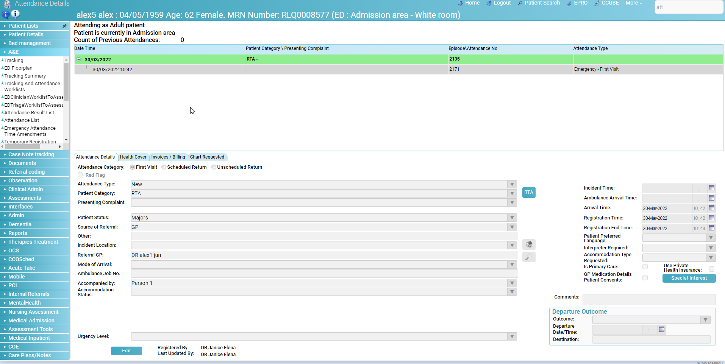
- Search for the ‘Tracking’ form, select your area on the left side. It has to match the area you selected in the attendance details.
- Select your patient and press ‘Assessment Details’.
- ‘Triage’ tab is opened and then press the ‘Order’ button.
- Wait 1 minute, press anything and you will be logged out to the log-in screen displaying no error.
- Log in and the ‘Patient Search’ form is displayed.

CHROME
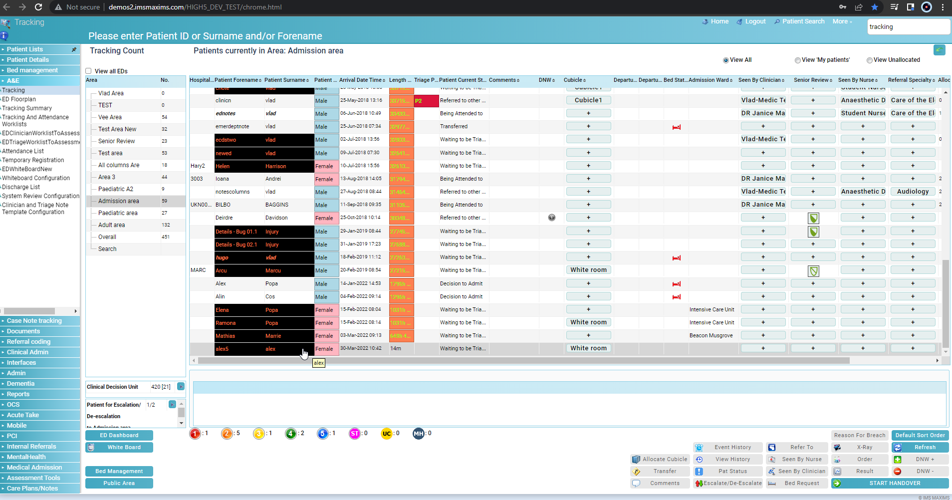

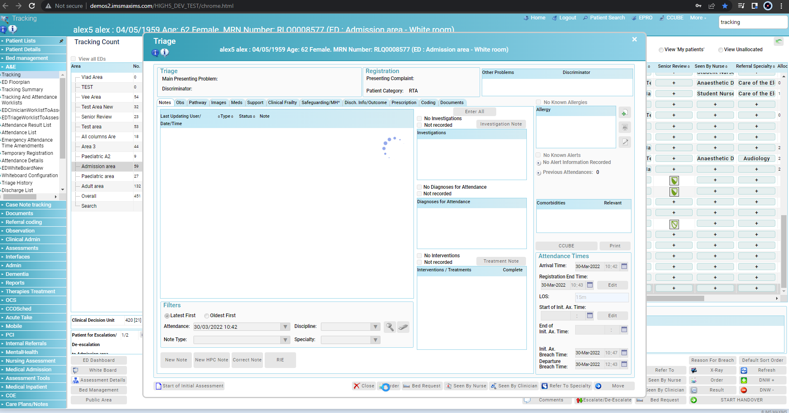
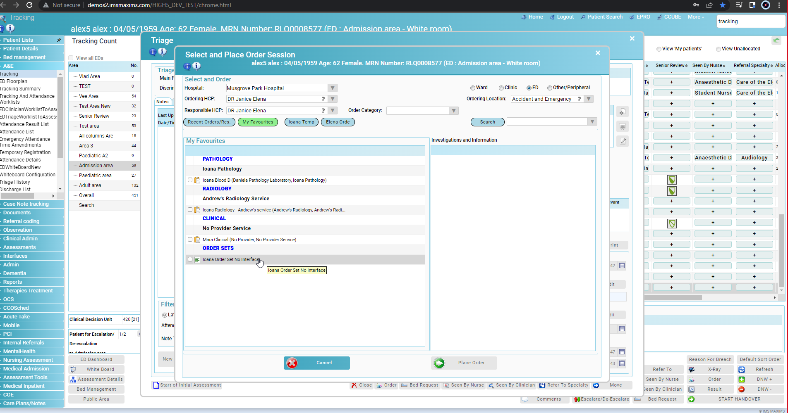
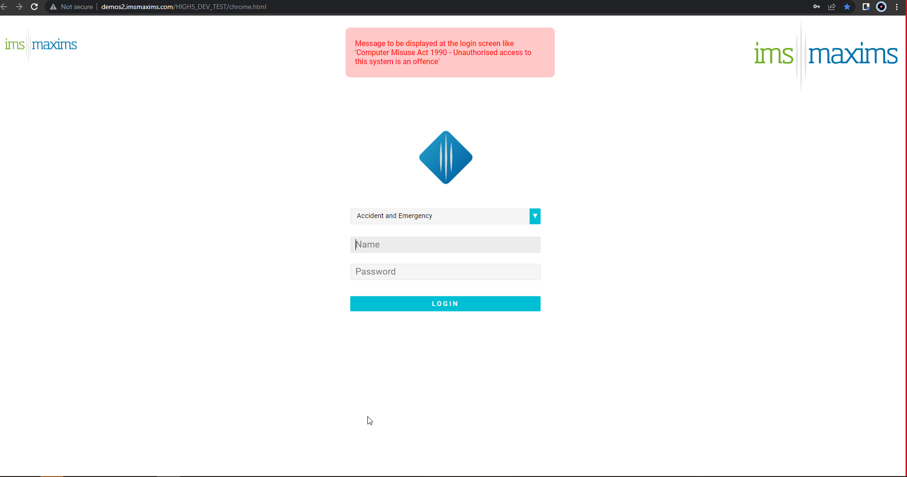
EDGE
